** Roll Gen™ System Spec Sheet**

**Date: Click here to enter a date. Name: Click here to enter text.**

**Company Name:** Click here to enter text. **Phone #: Click here to enter text.**

TMI DIMS NEEDED_.wmf

*Please reference the drawing above and record your dimensions below*

**Dimensions:**

|  |  |
| --- | --- |
| **A** | **Click here to enter text.** |
| **C** | **Click here to enter text.** |
| **D** | **Click here to enter text.** |
| **E** | **Click here to enter text.** |
| **G1** | **Click here to enter text.** |
| **G2** | **Click here to enter text.** |
| **H** | **Click here to enter text.** |
| **K** | **Click here to enter text.** |
| **TA** | **Click here to enter text.** |

**Belt Width: Click here to enter text.**

**Belt Speed (FPM or MPS): Click here to enter text.**

**Conveyor Run Time/Day: Click here to enter text.**

**Days/Week of Run Time: Click here to enter text.**

**Troughing Angle:** ☐ 20° ☐ 35° ☐ 45**°**

**Idler Diameter**: ☐ 5” ☐ 6” ☐ 7” ☐ Other Click here to enter text.

**Idler Part #:** Click here to enter text. **Idler Manufacturer:** Click here to enter text.

**CEMA Rating: ☐** B ☐ C ☐ D ☐ E ☐ Other Click here to enter text.

**Stringer Width:** Click here to enter text. **See Next Page for More…..**

**What are your intentions for the Martin® Roll Gen™ System?**

☐LED Lighting ☐ Compressor for Air Tensioner on Belt Cleaners

☐ Activation of Water Supply to Wash Box ☐ Initiation of Spray Bars

☐ Reversing Tracker Mechanism ☐ Firing of Air Cannon

☐ Any Other Application using 24 Volts DC ☐ Other Click here to enter text.

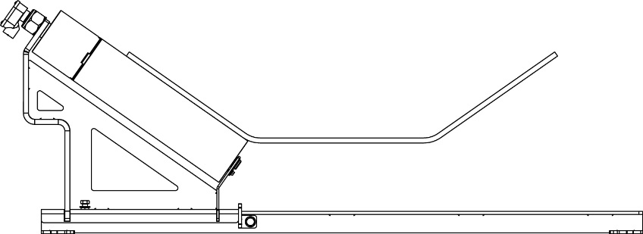

A

**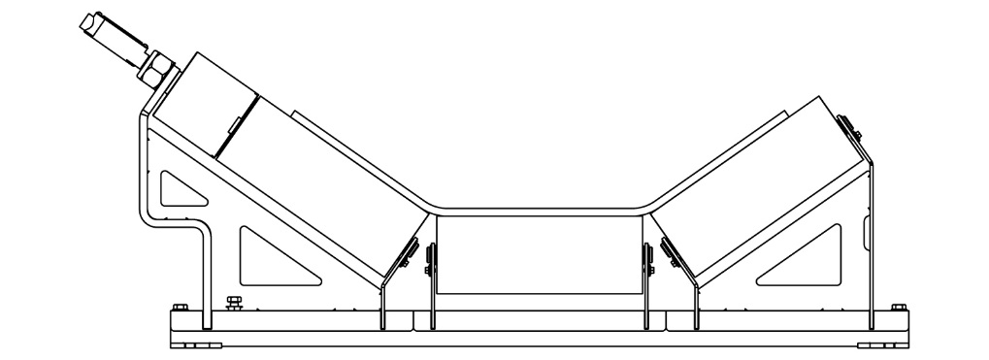**

B

**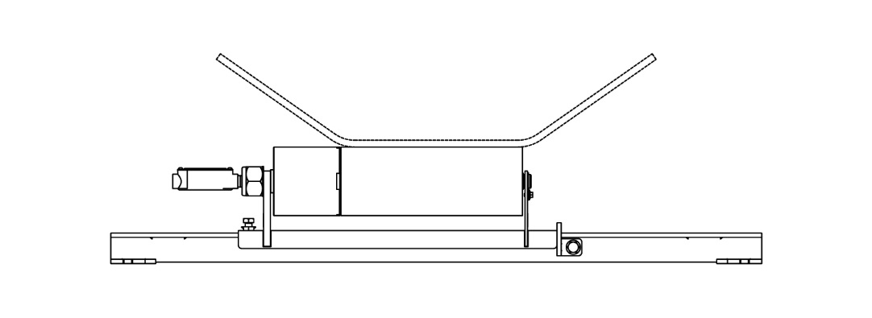**

C

**Which Configuration Above Are You Wanting?** ☐ A ☐ B ☐ C

**Quote #: Click here to enter text.**